**Project Introduction:**

**Task #1**

Create a Config Service REST api using Spring Boot that implements below apis to return and update JSON documents representing an application’s config properties.

The application needs to store the JSON documents in any SQL database using Spring Data JPA.

•       GET /api/{appCode}/config/{version} – return JSON document for specified appCode and version

•       POST /api/{appCode}/config/{version} – add new or update existing JSON document for specified appCode and version. JSON document should be included in the request body

•       GET /api/{appCode}/config – return list of available versions in JSON sorted by last modified date in descending order

**Task #2**

Create unit tests for task #1 (controller, service and repository layers)

**Project Overview:**

Project Structure:

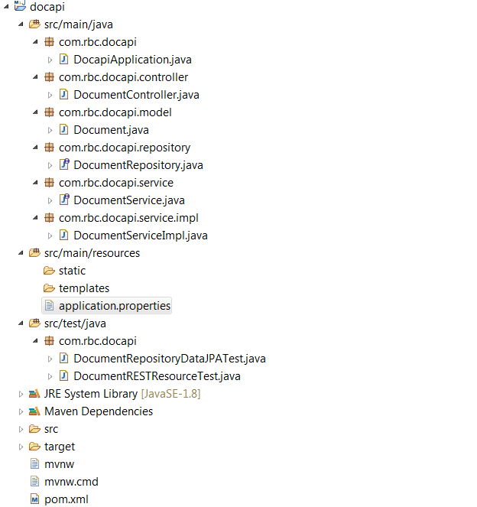

**Postman Unit Test:**

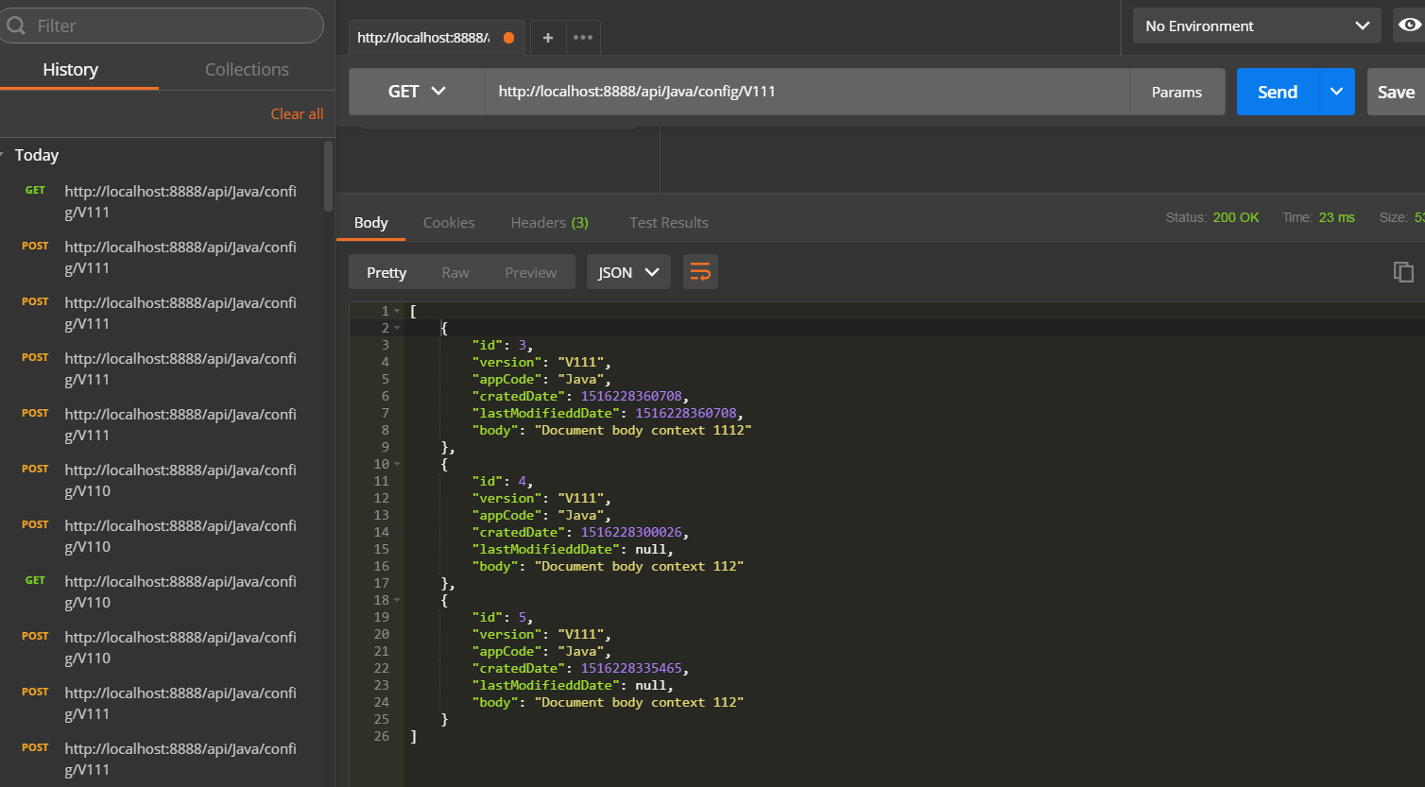

**How to run the project**

1) Clone project from GIT

2) Import into IDE like eclipse as exist Maven project

3) Build and run

2018/1/7

Jim Yeung.